**REGISTRATION FORM**

International Conference

On

“**POWER ELECTRONICS APPLICATIONS AND TECHNOLOGY IN PRESENT ENERGY SCENARIO**”

**(PETPES-2019)**

29th  - 31st August 2019

Name:………………………………….............................

Designation:…………………………...............................

Organization:……………………………………………..Address:…………………………………………………..………………………...……………………………….....…………………………………………………................

City:………………….......State:………………………...

Country:……………………… Pin:…………..................

Phone:………………….FAX:………………………...

Email:…………………………………............................

Mobile : ………………………………............................

**Payment details:**

Amount:…………….........DD no:………………………

Payee Bank:………………..Date:….…………………...

(DD should be drawn in favor of “The Director, NITK, Surathkal,” Payable at Surathkal)

Date:

Signature of the participant

Signature of Forwarding Authority with seal

Send to:

By Electronic Mail: petpes2019@gmail.com

or

By Regular Mail:

**Dr. P Parthiban**

Assistant Professor and Co-ordinator

Department of Electrical and Electronics Engg.

National Institute of Technology Karnataka,

Surathkal – 575025(Karnataka)

ORGANISING CHAIRS

**Dr. P Parthibanand Dr. R Kalpana**

Assistant Professor

Department of Electrical & Electronics Engg.,

NITK Surathkal

ADVISORY COMMITTEE

**Prof. Bhim Singh**

Dept. of Electrical Engineering, IIT - Delhi

**Prof. G. Bhuvaneshwari**

Dept. of Electrical Engineering, IIT - Delhi

**Prof. B. G. Fernandes**

Dept. of Electrical Engineering, IIT - Bombay

**Dr. Lakshminarasamma N**

Dept. of Electrical Engineering, IIT – Madras

**Prof. Pramod Agarwal**

Dept. of Electrical Engineering, IIT - Roorkee

**Dr. Siva Kumar K**

Dept. of Electrical Engineering, IIT - Hyderabad

**Dr. S. P Shrivatsava**

Dept. of Electrical Engineering, IIT- Roorkee

CONTACT ADDRESS

**The Organising Chairs -** PETPES-2019

E&E Department,

National Institute of Technology Karnataka,

Surathkal – 575025(Karnataka)

Tel.No : +91-824-2473468 *(office)*

+91-8762245244 *(Mobile)*

**Email: petpes2019@gmail.com**

*\** *Last date to submit nomination proforma along with the registration fee is 10th July., 2019.*

*\* Number of seats are limited and the admission will be done on first come first serve basis.*

International Conference

On

**POWER ELECTRONICS APPLICATIONS AND TECHNOLOGY IN PRESENT ENERGY SCENARIO**

**(PETPES-2019)**

29th – 31st August 2019

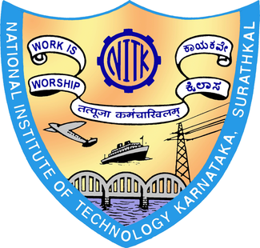

*Sponsored by*

**NITK-TEQIP Phase-III**

*Organized by*

**Department of Electrical & Electronics Engineering**

National Institute of Technology Karnataka (NITK), Surathkal, Mangalore-575025, Karanataka, India

(website:www.nitk.ac.in)



**Theme of the Conference**

Power electronics is the key to the present and future energy sector. The technology of power electronics has practically attained tremendous emphasis on wide spread applications in the areas of industrial, aerospace, electric utility systems, HVDC transmission systems, development of the concept of FACTS for efficient utilization and control of electrical energy. Power electronics is ushering in a new kind of industrial revolution because of its important role in energy conservation, renewable energy systems, bulk utility energy storage, and electric hybrid vehicles, in addition to its traditional roles in industrial automation and high-efficiency energy systems. It has emerged as the high-tech frontier in power engineering. This conference aims to cover the advancement and application of power electronics in present energy scenario. The conference aims to impart the current research into the analysis and design of power electronic converters for industrial applications and renewable energy systems. The importance of power electronics in energy efficiency improvement, renewable energy systems, electric hybrid vehicles and energy storage are the major concern of this conference.

**Conference Objectives:**

1. Bring together senior professionals in the field of power electronics to provide helpful information to younger professionals to stimulate the knowledge transfer from generation to generation.
2. Impart the current research into the analysis and design of power electronic converters for industrial applications and renewable energy systems.
3. Explore the recent power electronic technologies to use as an efficient interface in grid integration.
4. Emphasize on the importance and long-term viability of power electronics systems for renewable energy
5. Explore the recent and future applications power electronics systems.

**Conference Content**

* Advancement, application and grid integration of power electronics systems
* Power electronics application in photovoltaic, wind power and fuel cells
* Advance power converter/inverters and Industrial AC drives
* Micro grid & Power quality issues and mitigating techniques
* Challenges of present energy scenario and opportunities in power electronics area

**Resource persons**

Programme faculty includes experts from IITs, NITs and reputed Technical/engineering Institutes, experts from Industries.

**Target Participants**

Technical faculty, Utility/Industry person, Scientists, Research Scholars and Post graduate students from academic institutes would be benefitted from the conference.

**Registration Fee**

|  |  |
| --- | --- |
| **Participants** | **Fee(Rs)** |
| Regular Author  IEEE Author | 7100/-  6000/- |
| Student Author  IEEE student Author | 6000/-  4800/- |
| Regular Attendee  Student Attendee | 3600/-  2400/- |

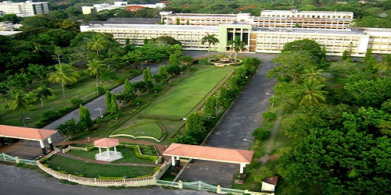

**About NITK**

NITK Surathkal is a premier Institution engaged in imparting quality technological education and providing support to research and development activities. NITK is recognized as an Institute of National Importance by an act of Parliament. NITK has carved a niche for itself among the best technical institutes in India. NITK offers 9 UG, 26 PG programs and PhD programs.

**Department of Electrical & Electronics Engineering**

The Department of Electrical and Electronics Engineering strives to be a Center of Excellence in education, training and research, producing high quality engineers and researchers. In this endeavour, the department will continually develop knowledge and quality of staff, upgrade and create new laboratory facilities, revise the teaching program, acquire adequate new equipment to keep abreast, contribute and progress in the emerging technologies and committed for rendering the best service to the society. The faculty of the department has been involved in several research projects in cutting edge technologies and publications in many international journals and conferences. The department also undertakes many consultancy projects from industry and other organisations.